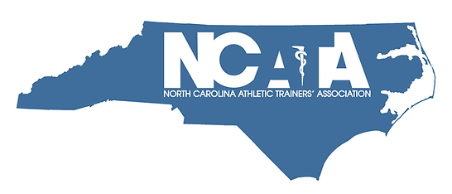

HALL OF FAME APPLICATION FORM
Candidates must submit the following documents to the NCATA President no later than Nov 1.
1. Completed NCATA Hall of Fame Application
2. Updated Curriculum Vitae / Resume
3. Three (3) Reference Forms
4. Digital Photograph for inclusion on NCATA website and HOF Plaque (if elected to HOF)

PERSONAL INFORMATION
Name:
Credentials:
NATA Member #:
NCBATE License #:
BOC Certification #:
NPI Number:
Place of Employment:
Work Address:
Work Phone:
Cell Phone:
E-Mail Address:
Social Media Handles (Instagram, X):
Ring Size:

PROFESSIONAL/EDUCATIONAL

Earned Degree | Institution | City/State | Year(s) of Degree or Attendance

CAREER HISTORY
Position | Institution | City/State | Year(s) of Employment

SECTION I: STATE CRITERIA
NCATA CLINICAL SYMPOSIUM ATTENDANCE (Indicate how many you have attended in the last 10 years)
1-4 | 5-7 | 8-10

NCATA SERVICE / BOARD OF DIRECTORS (List in chronological order ending with most recent)
Position/Title | Start Date | End Date

NCATA SERVICE / COMMITTEES (List in chronological order ending with most recent)
Committee | Title (Chair/Member) | Years of Service

NCATA CLINICAL SYMPOSIUM PRESENTATION (List in chronological order ending with most recent)
Meeting Title | Poster/Platform/Roundtable | Year

NCATA AWARDS (List in chronological order ending with most recent)
Award Title | Year

OTHER SERVICE TO AT BOARDS IN NC (NCBATE / NCATA PAC) (List in chronological order ending with most recent)
Position/Title | Start Date | End Date

LOCAL SERVICE (COMMUNITY SERVICE / CHARITABLE SERVICE) IN NC (List in chronological order ending with most recent)
Position/Title | Start Date | End Date

OTHER NC CLINICAL SYMPOSIUM PRESENTATION (List in chronological order ending with most recent)
Meeting Title | Location | Year

SECTION II: DISTRICT & NATIONAL CRITERIA
MAATA & NATA CLINICAL SYMPOSIUM ATTENDANCE (Indicate how many you have attended in the last 10 years)
1-4 | 5-7 | 8-10

MAATA & NATA SERVICE / COMMITTEES (List in chronological order ending with most recent)
Committee | Title (Chair/Member) | Years of Service

MAATA & NATA CLINICAL SYMPOSIUM PRESENTATION (List in chronological order ending with most recent)
Meeting Title | Poster/Platform/Roundtable | Year

MAATA & NATA SERVICE / BOARD OF DIRECTORS (List in chronological order ending with most recent)
Position/Title | Start Date | End Date
MAATA & NATA AWARDS (List in chronological order ending with most recent)
Award | Organization | Year

CAATE, NATA PAC, BOC SERVICE / BOARD OF DIRECTORS (List in chronological order ending with most recent)
Position/Title | Organization | Date(s)

PUBLICATIONS
List articles, chapters & textbooks published in the field of Sports Medicine in chronological order ending with most recent
Title | Journal/Publisher | Year Published

NATIONAL & INTERNATIONAL ATHLETIC TRAINING SERVICE
(ie: USOC, World Games) (List in chronological order ending with most recent)
Event | Title | Date(s)

OTHER CONTRIBUTIONS
List any other contributions to the profession of athletic training that have not been identified elsewhere (ie legislative work, sub- committee or committee supporting activities, preceptor, HOSA or leadership /AT recruiting groups etc):

COMMUNITY INVOLVEMENT
List any other community involvement or activities that would support this nomination (ie leadership at workplace, awards from local community, local initiatives)

